American Association of State Highway and Transportation Officials
Special Committee on Research and Innovation

FY2021 NCHRP PROBLEM STATEMENT OUTLINE

1. Problem Title
Machine Vision Interface with Light Emitting Diode (LED) Traffic Control Device (TCD) Displays

2. Background
Light Emitting Diode (LED) Traffic Control Device (TCD) displays utilize pulse width modulated drivers to stabilize the color matrix and control both light intensity and heat build-up. The individual LEDs or blocks of LEDs in a display rapidly flash on and off at a rate invisible to the human eye. In some full color matrix displays that contain Red, Green and Blue (RGB) LEDs the individual colors flash on and off at different rates. Preliminary information indicates a 60 – 240 Hertz (Hz) cycle in existing LED TCDs including pavement markings, signs and signals. In addition to TCDs, LEDs are prevalent in vehicle lighting (headlights, turn signals, brake lights, etc.) systems.

In an Automated Driving Systems (ADS) cameras are a sensor component capable of detecting an electronic display TCD and recognizing the message provided. ADS camera shutter speeds are typically set at high rates to avoid motion blur. The variation between the shutter speed of the detection and the refresh rates of the LED TCDs can lead to blank panels or display elements.

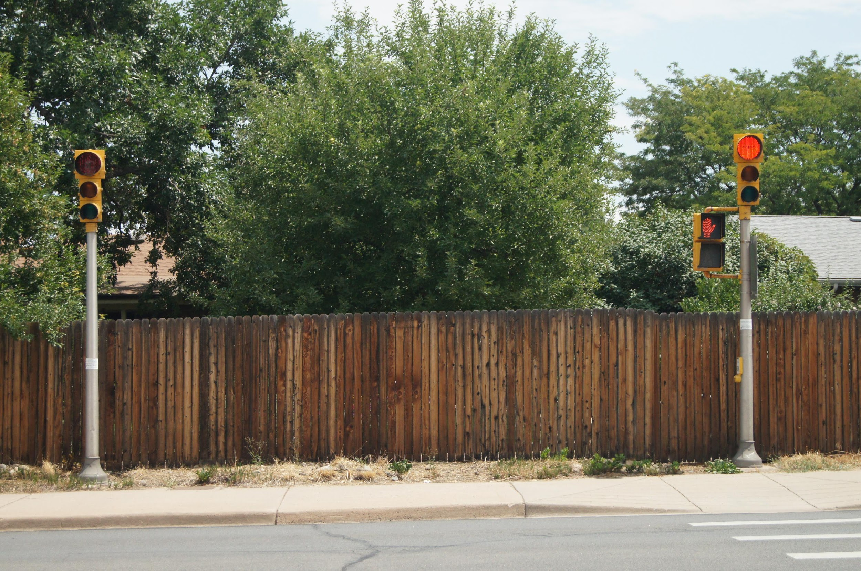
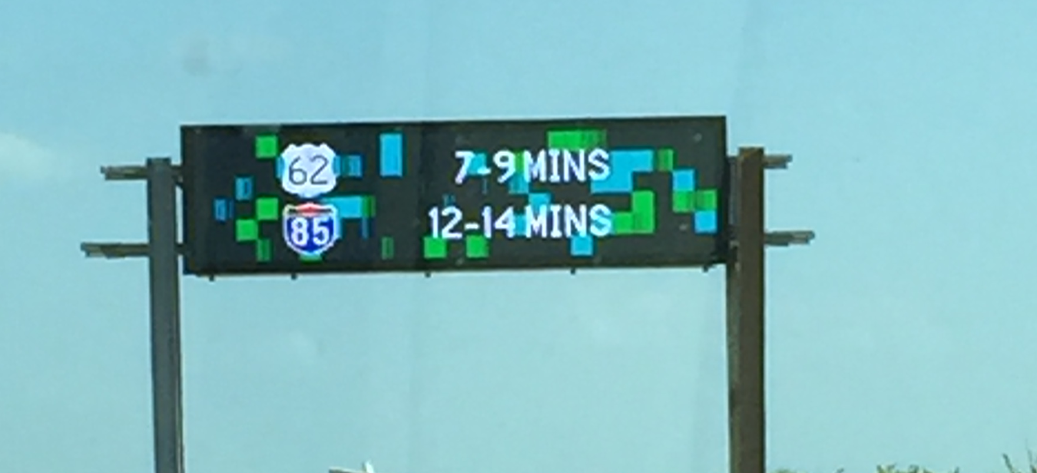
Figure 1: Flicker Example - Both red signal heads are lit to the human eye, however in this image, one signal head appears to be dark.
Figure 2: Ghosting Example - On a full color matrix sign, blue and green blocks appear in the image but are not visible to the human eye.

LED TCD displays are a critical element of the nation’s transportation system management operations (TSMO) infrastructure. LED TCD displays have a five (5) year for portable equipment to twenty-five (25) year life cycle for larger investments (such as overhead signals and dynamic message signs). Various reports on the nations automobile fleet replacement cycle indicates that the typical vehicle on the roadway is approximately 12 years old. Considering the long lead time for conversion of the nation’s automotive fleet and its transportation infrastructure, NOW is the ideal time to develop a collaborative, industry-supported ADS Machine Vision Interface with LED TCD displays. The solution could be embedded into several relevant standards and regulations that are currently scheduled to be updated including:

- National Electronic Manufacturers Association (NEMA), TS 4 Dynamic Message Sign standard
- American Association of State Highway Transportation Officials (AASHTO) A Policy on Geometric Design of Highways and Streets (Greenbook), and
- United Stated Department of Transportation (USDOT) Federal Highway Administration (FHWA) Manual on Uniform Traffic Control Devices (MUTCD)

This research effort is needed immediately to support the scheduled standard updates. Waiting ten years for the next update cycle to begin would negatively impact the safe deployment of TCDs compatible with automated vehicles within the normal equipment replacement cycle.

3. Literature Search Summary
TRID Search terms: “Machine Vision” and “LED” , “LED Flicker” and “ADS Machine Vision” produced no recent and directly relevant projects. The existing body of research does not address the relationship between the image creation (LED) and the image capture and processing needed for automated vehicles to respond appropriately to LED traffic control device displays.

4. Research Objective
The objective of this research is to initiate cooperative and collaborative work between the automotive industry, traffic control device industry and infrastructure owner-operators in a partnership to improve the potential for TCD LED display detection and comprehension via the ADS machine vision (camera or other sensor) interfaces, facilitate information processing by the ADS and support the safe deployment of ADS on the nation’s transportation network. The major tasks or activities of the work should include:

Phase I:
- Identification of all known relevant material, equipment and process constraints of automated vehicle sensors and LED based automotive and traffic control device equipment including a global assessment of automotive and electronic equipment state of the practice.
- Identification of motion blur, sensor sampling speed (camera shutter speed or similar), vehicle speed, and ADS data processing function interdependencies.
- Identification of all related and affected standards such as NEMA TS 4 and TS 10 or Institute of Transportation Engineers (ITE) signal specifications.
- Identification of all components that must be modified or considered when attempting to resolve the sensor and LED equipment pairing such as LED refresh rate, sensor sampling speed, and data processing.
- Development of a work plan to identify economical and feasible equipment standards proposals that address the ADS sensor and LED equipment pairing issue.
- Include in the work plan, an outreach effort to coalesce the various industries around the proposed standards and facilitate the ability of ADS sensors to detect and read LED TCD and automotive displays.

Phase II:
- Execution of the work plan
  - Establish sensor sampling speed range acceptable from a motion blur and image capture perspective (e.g., Nyquist frequency).
  - Establish LED pulse width modulation (PWM) cycle range that will ensure multiple cycle completions during the sensor sampling range.
  - If all LED TCD and automotive devices can be operated within the PWM cycle range, then information to be shared with industry standards groups else begin exploration of alternative solution methods such as:
    - multiple image integration.
    - localized signal to indicate when LED image will be available for sensor read (established time to “on-state”)
    - other…..
- Outreach plans to include:
  - AASHTO, USDOT FHWA and State Department of Transportations
  - National Committee on Uniform Traffic Control Devices (NCUTCD)
  - ITE (Signal Specifications) and NEMA (TS 4 and TS 10 standards)
  - International Municipal Signal Association (IMSA)
  - Society of Automotive Engineers (SAE)
  - and American Society for Testing and Materials (ASTM)

Deliverables:
- Literature Search and Industry Survey
- Establishing current industry state of the art Machine Vision interface Average Driver measurements – Eye Height, Cone of Vision, Sensor Sampling Speed, etc.
- Establishing current industry Light Emitting Diode (LED) modulation state of practice (flicker) measurements.
- Identifying related and potentially impacted industry (ASHTO, CIE, IEEE, IESNA, ITE, NEMA, SAE, NTCIP, etc.) standards and specifications.
- Identifying related and potentially controlling regulations such as FCC Part 15.
- Draft Document and Research Plan
(**May require a Phase II Work Plan if laboratory testing and proof of concept work required**)
- Develop and Test methods for improving the Machine Vision interface detection and interpretation of LED traffic control devices.
- Laboratory Testing (proof of concept)
- Final Document (Report) and Peer Exchange
- Summary of ADS Sensor and LED TCD state of the art
- ADS Sensor and LED TCD specification recommendations.
- Outreach material (presentation) to inform affected regulatory, standard and specification committees such as the NCUTCD, AASHTO, SAE or others of the proposed best practice.

5. Urgency and Potential Benefits
This research effort is needed now to support scheduled standards updates. A collaborative, industry-supported solution would improve the potential for TCD LED display detection and comprehension via the ADS machine vision (camera or other sensor) interfaces, facilitate information processing by the ADS and support the safe deployment of ADS on the nation’s transportation network. This work will facilitate the preparation of the nation’s transportation network and the national automotive fleet to support the safe deployment of ADS vehicles.

6. Implementation Considerations and Supporters
To aid the AASHTO R&I Committee in deciding whether to fund this project, describe:
- Who within a state DOT will likely be responsible for using the research results. IT, ITS, Traffic and TSMO Groups.
- How state DOTs can implement the research within their own organization and what major steps they would need to take. Adopt new standards and incorporate those standards into on going and future purchasing efforts.
- What existing venues or processes could be used to support implementation. AASHTO, ITE, NCHRP, NEMA, SAE and TRB conferences, committee meetings, document and standards distribution.
- What kinds of additional products and activities (for e.g. brochures, summaries, presentations, training workshops, peer exchanges, pilot testing, and verification and validation of the research results) will help create awareness and facilitate implementation of the research results. Training workshops, pilots and peer exchanges.

List the AASHTO Committee(s) and/or Council(s) – and any other organization – that might be interested in the research results and could help support implementation.
- AASHTO Committee on Materials and Pavements (COMP)
- AASHTO Committee on Traffic Engineering (CTE)
- AASHTO Committee on Transportation System Operations (CTSO)
- American Traffic Safety Services Association (ATSSA)
- Illuminating Engineering Society of North America (IESNA)
- International Commission on Illumination (CIE)
- International Municipal Signal Association (IMSA)
- Institute of Transportation Engineers (ITE)
- National Committee on Uniform Traffic Control Devices (NCUTCD)
- National Electrical Manufacturers Association (NEMA)
- Society of Automotive Engineers (SAE)
- USDOT, Federal Highway Administration (FHWA)
- USDOT, National Highway Traffic Safety Administration (NHTSA)

7. Recommended Research Funding and Research Period
It is estimated that this project, at an accelerated pace, can be completed at a cost of $250,000 if the compatibility issue can be resolved based on the gathering of available information. The accelerated pace would facilitate contribution to industry standards already under review and scheduled for updating as well as presentation of proposed outcomes during the January 2022 industry forums such as the TRB annual meeting, NCUTCD Winter Meeting and ATSSA Expo. Data collection, solution and documentation should be completed in 12 months with outreach occurring over the next 6 months. Additional funding ($200,000) and time (12 months) may be required if a Phase II work plan for laboratory testing and proof of concept is required to create a solution.

8. Problem Statement Author(s)
Members of the National Committee on Uniform Traffic Control Devices, Guide and Motorist Information (GMI) and Regulatory and Warning Signs (RWS) Technical Committees (TC) Signs for Connected and Automated Vehicles (CAVs) Joint Task Force (JTF).
- Roxane Y. Mukai, Operations Engineer, Maryland Transportation Authority, 410-537-8389, rmukai@mdta.state.md.us (Co-Chair, NCUTCD GMITC and RWSTC CAV JTF)
- Paul Ciupa, AECOM, pciupa4800@gmail.com. (Retired Cuyahoga County, NCUTCD IMSA delegate)
- Jose Herrera-Alonso, Regulatory Affairs Specialist, 3M, 651-736-9648, jherreraalonso@mmm.com
- Joanne Conrad, Senior Regulatory Specialist, Tapco, 262-649-5200, joanne@tapconet.com. (Vice Chair, ATSSA Sign Committee)
- John Hansen, Principal, 2ITSHelp, 719-330-4402, jhansen@2itshelp.com. (NCUTCD ITE associate delegate)

- Others Supporting the Problem Statement
- ATSSA Sign Committee, Angel Ramos(staff) and Joanne Conrad (Chair), 540-729-1951, angel.ramos@atssa.com
- IMSA, Toby Cummings and Paul Ciupa (NCUTCD Delegate), 321-349-3600, toby_cummings@imsasafety.org
- ITE President, Ransford S. McCourt, 503-753-8996, randy.mccourt@gmail.com
- NEMA, Steve Griffith and Kezhen Shen (TS-4 and TS-10), 703-841-3288, kezhen.shen@nema.org

- Potential Panel Members
- Organization, contact person, phone number and email address

If this problem statement is submitted by an AASHTO Committee or Council, please recommend Committee or Council members as potential panel members.
- Member name, state, AASHTO Committee or Council, phone number and email address

11. Person Submitting the Problem Statement
Provide contact information for the individual submitting this problem statement.
- Name of individual
- Phone number
- Email address
- Affiliation (limited to): [state] DOT
FHWA [office]
AASHTO [Committee or Council]
AASHTO staff on behalf of the AASHTO [Committee or Council]

Please submit the problem statement by:
Midnight EST on November 1, 2019: http://bit.ly/NCHRPFY2021

Late submittals will not be accepted.

Questions on the process can be directed to Lori Sundstrom at lsundstrom@nas.edu

IHS Markit https://news.ihsmarkit.com/prviewer/release_only/slug/automotive-average-age-cars-and-light-trucks-us-rises-again-2019-118-years-ihs-markit-

